# PROJECT DESIGN PHASE-I

SOLUTION ARCHITECTURE

|  |  |
| --- | --- |
| DATE | 11 October 2022 |
| TEAM MEMBERS | DANUSH HARI, DHAYABARAN, BARATH RAJ, BIBIN, GOWTHAM |
| PROJECT NAME | Project – Intelligent Vehicle Damage Assessment and Cost Estimator For Insurance Companies |

SOLUTION ARCHITECTURE :

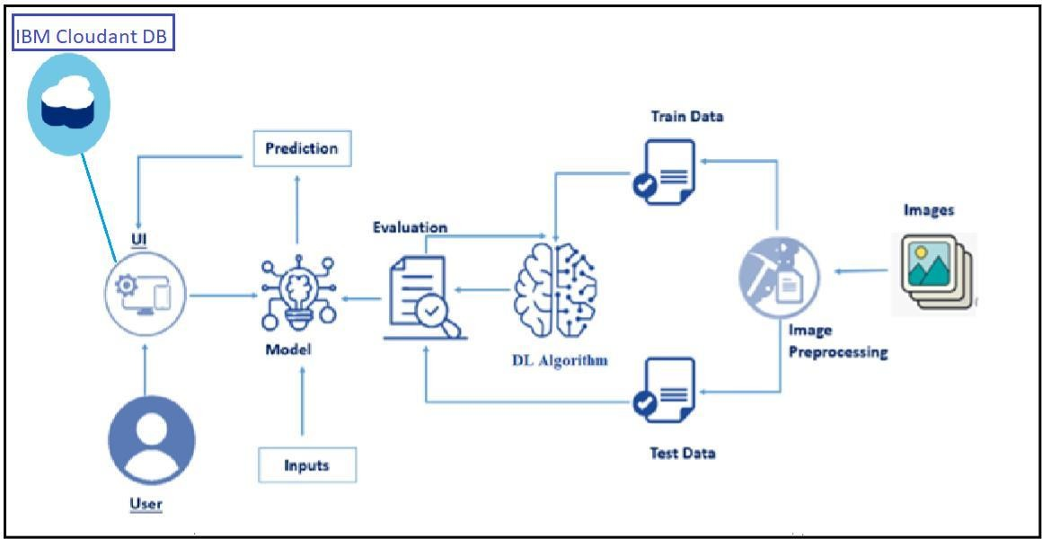

# OUTLINE ARCHITECTURE :

